# Pricing Recommendation for Big Mountain Ski Resort

## Guided Capstone Project Report

### By Aisling Casey – February 6th, 2021

# Problem Identification

Big Mountain Resort is a word-class ski resort in the Montana Rockies, boasting 350,000 visitors a year. However, the resort’s pricing scheme is too blunt. It is above average for the resort market, but it is not clear that this amount properly values the resort’s services. Furthermore, it is not clear where future investments should be made for greatest ROI. A new 1.5 million chair lift was just installed, and the business is looking for guidance on setting a better value for their ticket price.

The solution space for this issue lies within ticket price adjustments, cost reduction and/or further facility investment. Data on the assets & prices of ski resorts across the US will inform the model of Big Mountain’s asset worth.

Problem Statement: Big Mountain Resort must take better assessment of the worth of its assets to set more competitive prices. This, along with cutting operation costs, should be evaluated to see if they can increase company profits by the end of the next ski season.

# Model Insights

The model most accurate in predicting the Adult Weekend ticket price was selected. This model determined the following features most important in predicting this variable: fast quads, number of runs, snow making acreage, vertical drop and skiable terrain.

Big Mountain is a market leader in snow making acreage with a value of 600 compared to a 3rd IQR of 184. However, ticket price position in the market is disproportionate to this feature, at $81 a ticket compared to a 3rd IQR of 78. This discrepancy is illustrated by the distributions on the right. Since this feature critical in predicting ticket price, it supports the increase of Big Mountain’s Ticket price.

Big Mountain is also a market leader in many other categories, though not to the same degree as snow making acreage. For example, the 3rd IQR of number of runs for the market is 55, while big mountain has 105 runs. Furthermore, Big Mountain is one of the few resorts to offer fast quads, let alone 3 of them. Only 13 resorts have more than 3 fast quads; thus, Big Mountain is a leader in this feature as well.

# Key Findings & Recommendation

Currently, Big Mountain resorts charges $81 for an Adult Weekend ticket; the model suggests a price of $95.87, based on the facilities offered at Big Mountain compared to those at other resorts and their prices. Thus there is room for a price increase, though the expected mean absolute error of $10.39 must be taken into account. At minimum, the model supports a $4 increase to ticket price, yielding an estimated 7 million in revenue for the year.

Perhaps due to the remoteness of the resort, it was priced at a lower value than it should have been. This model proves that this characteristic of the resort should not be as penalizing, considering the strengths of the resort in many areas relative to the rest of the market. Big Mountain resort is a market leader in model-crucial features such as including snow making area and number of runs.

Four other proposed facility changes were evaluated against their effect on the predicted price. Two were determined to be worthwhile, while the other two lead to no increase in the projected ticket price.

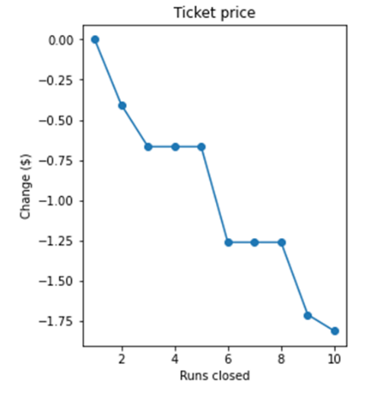The first viable suggestion was to remove between 1-10 runs. The change in predicted ticket price vs. number of runs closed is depicted on the right. At minimum, one run can be removed to save on cost with negligible effect on the ticket price. From there, the drop in projected ticket price for the season must be evaluated against the savings associated with closing the corresponding number of runs (the author does not know this information at present).

There is a tiered result to be noted; there is no difference in the predicted price change between closing 3 and 5 runs, so if it is determined that closing 3 runs is worthwhile, 5 runs may as well be closed. The same is true for closing anywhere from 6 to 8 runs.

The second viable proposed change was to increase the vertical drop by adding a run to a point 150 feet lower down, but requiring the installation of an additional chair lift, without adding any additional snow coverage. This supports an additional ticket price increase of $2, which projects an overall 3.5 million in added revenue. Should the cost of this endeavor be significantly less than this projected revenue increase, then it is recommended.

# Looking Ahead

The utility of this model is not only to recommend the overall Adult Weekday price for the result, but also that it can quantify the value of removing or adding a facility. Business analysts can use this model to assess future suggestions for cost reduction or investment opportunities.

To make more specific recommendations in future work, it will be necessary to know the operating costs of various facilities, such as snowmaking, adding a new chairlift and so on. It would also be helpful to know the prices of other services offered by the resort compared to other resorts - the hotel, food, various activity packages, etc. These could really set the resort apart from others. Given its remoteness from major population centers, these amenities are important for understanding the value the resort offers.